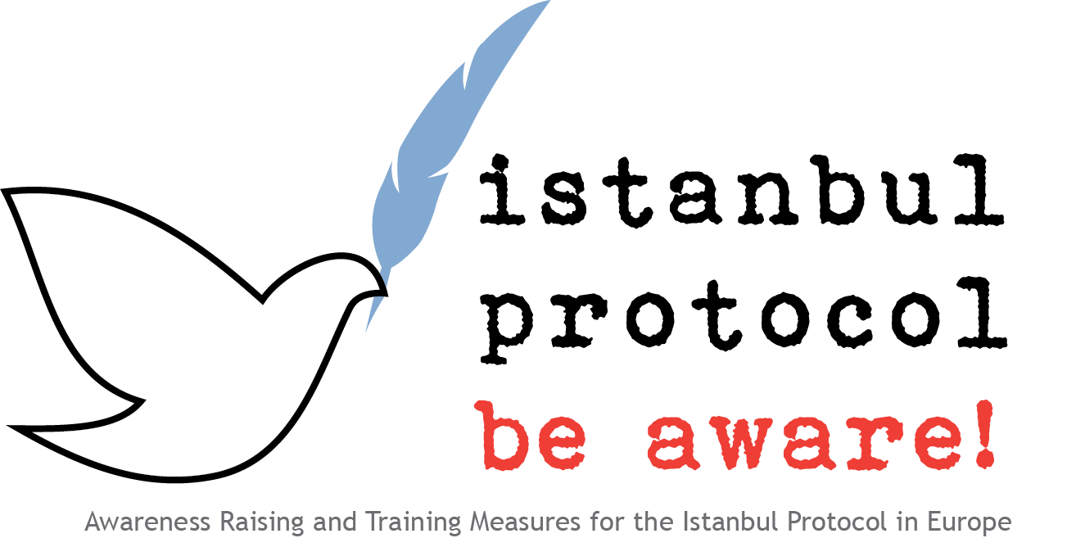

Assessment of post-traumatic stress by questionnaire

In any exercise or training focusing on post-traumatic stress, four key issues should be considered:

First: post-traumatic stress disorder is a very common, specific and relevant reaction to torture, but by no means the only one. It should always be clear, that an assessment of mental health after torture must follow a comprehensive approach and cannot be limited to PTSD.
Two: cultural factors must be considered in this context. Symptoms of post-traumatic stress might take different forms, and might be perceived and addressed differently based on culture. This problem is usually not addressed by standard questionnaires on post-traumatic stress disorder.
Three: questionnaires cannot replace the sorrow clinical interview and assessment. They can help in screening, though it should be considered, that fear of psychiatric stigma might lead to falls negative results. A structured clinical standard interview, especially the very precise CAPS that suffers from the limitation that it covers only PTSD and the SCID that also covers other psychiatric disorders generally yield substantial information in a structured way. Structured clinical interviews usually require a special intense training by experts.
Four: complex, social psychological symptoms such as shame and guilt feelings have been identified to be of major importance in suffering and chronicity. They are only covered by a few of the standard instruments, such as the Harvard Trauma Questionnaire, and the CAPS.
As part of the trainings, assessment of the simulated case using such questionnaires can be a helpful exercise, as long as the above mentioned considerations are kept in mind. In using assessment of post-traumatic stress as part of the training exercises, it is important to be aware, that victims in a group might suffer themselves from post-traumatic stress, and an exercise can trigger intrusive memories. It is in the responsibility of the trainer to explain this issue prior to an exercise and to identify and support possible reactions as part of the training.

We have included common and publicly available standard questionnaires in the project trainers Toolbox, but recommend using the Harvard trauma questionnaire.

http://www.clintools.com/victims/resources/assessment/ptsd/protected/CAPSIV.pdf
First, Michael B., Spitzer, Robert L, Gibbon Miriam, and Williams, Janet B.W.: Structured Clinical Interview for DSM-IV-TR Axis I Disorders, Research Version, Patient Edition. (SCID-I/P) New York: Biometrics Research, New York State Psychiatric Institute, November 2002.
Mollica, R F, Y Caspi-Yavin, P Bollini, T Truong, S Tor, und J Lavelle. „The Harvard Trauma Questionnaire. Validating a cross-cultural instrument for measuring torture, trauma, and posttraumatic stress disorder in Indochinese refugees“. The Journal of nervous and mental disease 180, Nr. 2 (Februar 1992): 111–116.

