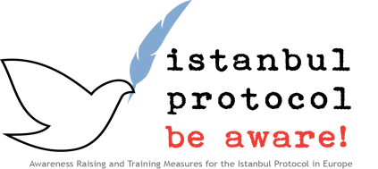

Case 2
Complexity: simple
Target groups all

Note: The following case presentation selects specific questions from a complete and journal examinations.

A 40 five-year old female refugee is referred for examination because of apparent contradictions in her first interview and in additional claims made and submitted by her lawyer at a later stage of the asylum process. While she had reported in her initial submission and interviews, that she only had been beaten on all parts of the body, she later stated that she had been raped during torture. Imprisonment and torture as alleged by the client had been described to have happened two years before she had escaped her home country and applied for asylum.
Medical findings provided by her general practitioner in the host country based on general medical eczema nation but not including a full mental health status did not yield any pathological findings. This fact was used as one of the arguments to refuse her claim. Further arguments included contradictions between the different submissions and facts reported later. Declined later was forcefully returned to her home country. Review of the case by a human rights organisation indicated that she had been arrested by special police immediately after her return and contact was lost.

Questions:

- Do the contradictions and later reporting of some important facts actually disprove the credibility of the client ?
- Which explanations could be given for contradictions and belated reporting of rape ?
- Which additional medical steps should have been taken ?

Answers:
- Do the contradictions and later reporting of some important facts actually disprove the credibility of the client ?
No. Severe physical and psychological violence frequently lead to problems in concentration, memory, memory recall, coherence of reporting.
- Which explanations could be given for contradictions and belated reporting of rape ?
Especially in sexual violence it can be difficult or impossible to report events leading to severe shame or guilt feelings in initial interviews. Special steps as indicated in the Istanbul protocol must be taken to both protect a possible victim against renewed traumatization and address apparent contradictions. Besides the psychological factors such as shame and guilt feelings physical injuries such as brain trauma and reactive psychological disorders such as posttraumatic stress disorder and depression, that are very common in victims of violence, must be taken into consideration.
- Which additional medical steps should have been taken ?
Taking a mental health’s status examination, even in a basic form, and even if stigmatised in the local culture, should be included following the cautions and guidelines provided in the Istanbul protocol. Additional diagnostic procedures including for example nuclear magnetic resonance to demonstrate or exclude blunt brain injury imaging or bone scintigraphy to assess possible bone damage should have been offered, or the lack of the use mentioned. negative findings and there possible background and implications, should have been discussed in the finding to alert the asylum court to the limited scope of possible conclusions.

