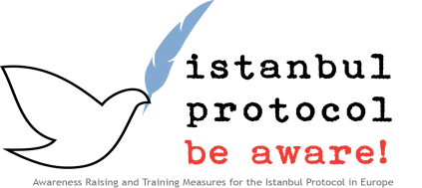

# Examples for using ARTIP materials to develop a practice oriented exercise

### The project platform

The project platform offers a number of tools that can be used to create practical exercises in the group. It should be considered that Istanbul Protocol and the process of documentation, interdisciplinary activities. While some tasks require a specific medical, psychological or legal background profession, many steps in documentation should be at least understood, if not performed by all professionals. Further tools will be uploaded as an ongoing process, so please have a look in the relevant sections of that platform.

### Why interdisciplinary exercises with all participant groups

It can be for example necessary, that during a prison visit no psychologist or forensic photographer is available, still the best possible effort should be taken to document psychological aspects of the setting, problems of the client, and take pictures of injuries and prison conditions or possible tools of torture.  
  
All reasonable basic skills should therefore be mastered by all participants, especially in a COLE interdisciplinary learning environment.  
  
  
Taking pictures

Taking pictures can therefore be a very good practical exercise. Even with simple equipment and basic technical knowledge, pictures can be provided that are sufficient or at least better than no pictures. If additional tools and equipment is available, such as a ring light,   
they can be demonstrated and used to encourage the production of more efficient visual documentation. Especially in prison visits and places of detention video should be included to document the general setting and prison conditions.   
  
The tools provided by the project include the simple ruler that can be printed out either on transparent or white paper, the photo documentation sheet that can improve documentation quality internal and record important additional information, the timeline that can be used in its different formats to correlate report and injuries, and several documents that give guidance on how to improve visual documentation.   
  
The body schema sheet in the protocol annex can also be used in the exercise, and participants should read the relevant parts of the protocol. The case examples can be used to further improve the hands on experience. You can also get an excellent ruler from IRCT ([www.irct.org](http://www.irct.org)), together with a larger manual (“Photographic documentation, a practical guide for non professional forensic photography”).  
  
  
C:\Users\T W\AppData\Local\Microsoft\Windows\Temporary Internet Files\Content.IE5\4Y0ARWAQ\MC900217198[1].wmf

If you add a mock trial, you can for yourself experience the different impact of reports simulated with no, insufficient and best as possible visual documentation.