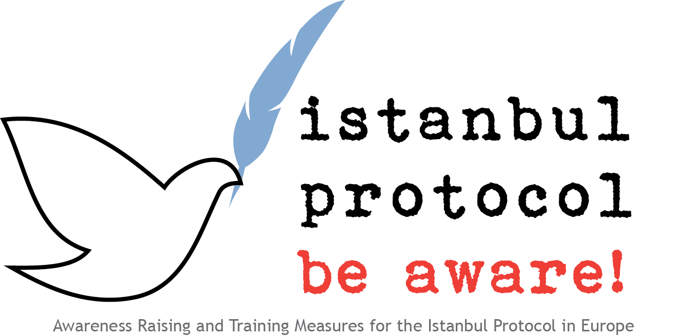
Trauma and consequences of human rights violations - an interdisciplinary challenge

Thomas Wenzel, Stefanie Pichler

Contents

Introduction 3
Consequences of violence and trauma 3
Psychological consequences of serious violence as an example for relevant questions 3
Post-traumatic stress disorder 4
Differential diagnosis : traumatic brain injury 6
Non-specific reactive disorders 7
Epidemiology of Mental consequences of violence and indirect victims 7
Indirect victims 8
Treatment 8

Introduction

Consequences of violence and trauma
Particularly severe stressful life events such as accidents, natural disasters and violence are often accompanied by severe long-term consequences.
According to recent estimates by the World Health Organization (WHO) severe physical and psychological violence can be the most serious and consequential problems in health care in many countries of the world.
Physical and psychological violence is essentially similar in importance for health care as infectious diseases or cardiovascular diseases. Similar to a close linkage of social and health problems in other areas, an interdisciplinary approach plays a significant role in terms of understanding, prevention and intervention and treatment.
In addition to domestic violence or violence in families and violence against ethnic and social minorities, political violence, including torture, civil war abuses and other forms of serious human rights violations plays an increasing role in the perception of the United Nations, the EU and in the international law, and the professional umbrella organizations of health professionals - especially the World Health Organization, the World Association of Psychiatry and the World Medical Association.
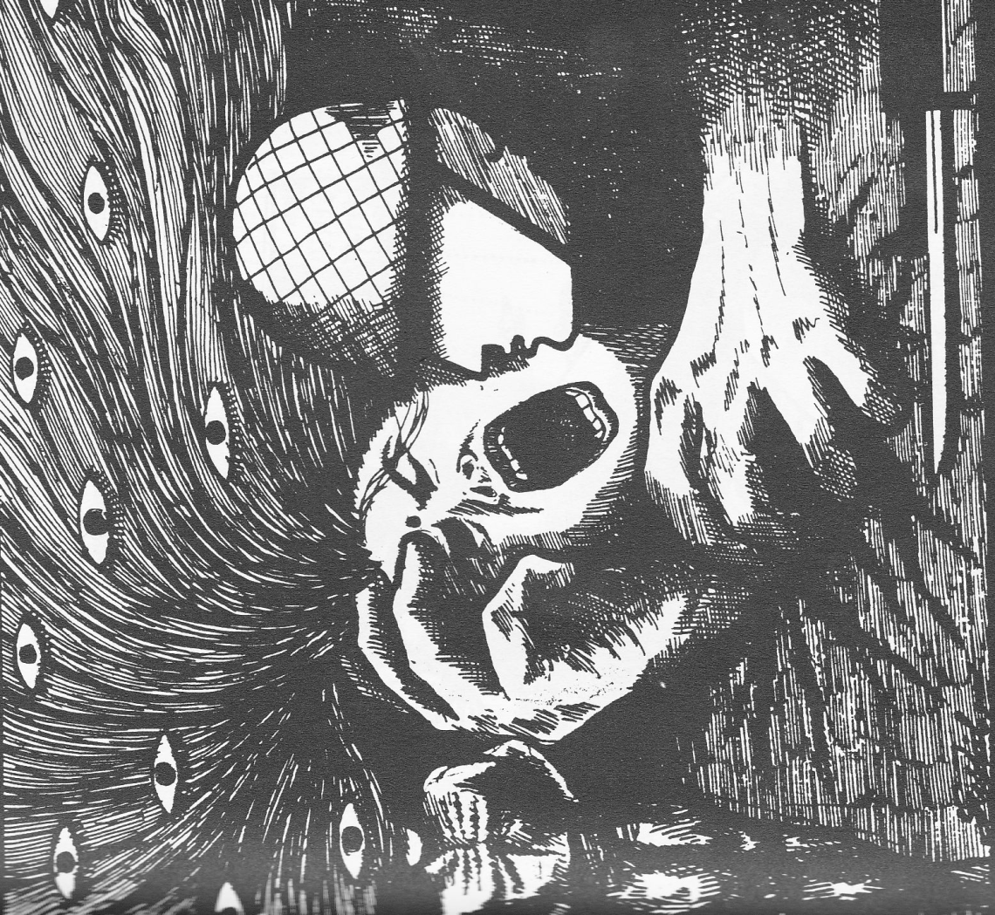
(Source: CVICT (Centre for Victims of Torture Nepal))
The Istanbul protocol reflects this special concern by providing a medical, but also interdisciplinarity document to guide training in that documentation and assessment of torture and inhuman and degrading treatment as one of the most important forms of violence.

Psychological consequences of serious violence as an example for relevant questions in the assessment of victims

Characteristic consequences that are relevant to an investigation or treatment of potential victims of violence should be summarized following first the probably most common and serious psychological trauma-related disorders.
Besides its obvious importance for treatment, post traumatic disorders represent an essential factor for an assessment, as post traumatic disorders represent quite often the long-term consequences.
The diagnostically characteristic impairment of memory, concentration and retentivity and avoidance of burdensome memories as self-protection, which can be a possible evidence of persecution and experienced violence, may affect the quality and completeness of the testimony of the victim substantially, especially if these experiences/symptoms are severe and untreated, which occurs quite often.
Often overlooked factors such as traumatic brain injury that may have similar symptoms as the post-traumatic stress disorder underline the importance of a multidisciplinary and comprehensive diagnostics.
First by observations within and as a result of World War II, increasingly since the Vietnam War, it became clear that such experiences in addition to severe physical injuries have serious long-term effects on psychological and neuropsychological area that are not associated with significant physical injury.
In addition to previous approaches, such as the concentration camp survivors or torture syndrome specific disease categories are more concretely defined since last two decades, which is more secured due to neuropsychological, psychological and socio-psychological models.

Post-traumatic stress disorder

Tabel I : ICD 10 Definition F43.1 Post-traumatic stress disorder
Arises as a delayed or protracted response to a stressful event or situation (of either brief or long duration) of an exceptionally threatening or catastrophic nature, which is likely to cause pervasive distress in almost anyone. Predisposing factors, such as personality traits (e.g. compulsive, asthenic) or previous history of neurotic illness, may lower the threshold for the development of the syndrome or aggravate its course, but they are neither necessary nor sufficient to explain its occurrence. Typical features include episodes of repeated reliving of the trauma in intrusive memories ("flashbacks"), dreams or nightmares, occurring against the persisting background of a sense of "numbness" and emotional blunting, detachment from other people, unresponsiveness to surroundings, anhedonia, and avoidance of activities and situations reminiscent of the trauma. There is usually a state of autonomic hyperarousal with hypervigilance, an enhanced startle reaction, and insomnia. Anxiety and depression are commonly associated with the above symptoms and signs, and suicidal ideation is not infrequent. The onset follows the trauma with a latency period that may range from a few weeks to months. The course is fluctuating but recovery can be expected in the majority of cases. In a small proportion of cases the condition may follow a chronic course over many years, with eventual transition to an enduring personality change (F62.0). inclusive traumatic neurosis

As a persistent fight, flight and alarm response after surviving a dangerous situation which remains in safety, this reaction is usually seen as physiological and survival. Symptoms persist and interfere with daily life and quality of life and a meaningful response pattern develops into a serious medical condition. Likewise, in the asylum procedure, the recognition and symbolic support of political persecution in addition to the important function of protection against the threat of new and renewed deportation to torture or murder has an important psychological role. Lack of protection can reactivate fears in the context of PTSD and related disorders.
This general context should be explained to the patient, who frequently is disturbed by the symptoms themselves and feels like being week or crazy, which is stigmatised condition in most cultures. Confirming that symptoms are a normal reaction to not normal conditions is an important step of therapy that is already taken during examination.
Besides being affected by agonizing memories (as flashbacks may even supplant the perception of the immediate real situation), intense nightmares, severe initiating and maintaining sleep, increased irritability and startle response, which often leads to social conflicts and family problems, everything is avoided what can practically reminder of the trauma experienced.
The disturbance of concentration and memory, as well as a dissociative symptoms with episodes of "absence" and gaps in memory, also contribute to serious social and emotional consequences.
In addition to combinations such as the emergence of alcohol or benzodiazepine abuse as part of self-treatment attempts and depressive exhaustion, sometimes conflicts with the social environment occurs. Social problems are reflected in the well-documented high divorce rate, for example, in war veterans and professional paramedics.
This is an important risk to be considered in a e.g. forensic examination. Even though a clinical diagnosis is enough due to the very unique state image, numerous diagnostic questionnaires (such as the Harvard Trauma Questionnaire) and standard interview instruments are available, especially necessary in the forensic evaluation or research and for monitoring in the progress of treatment.
Since the first studies on the effects of concentration camp imprisonment it was known that, paradoxically, victims of criminal or political violence often feel ashamed or guilty. For the first time the phenomenon of survivor guilt has been described in this context. Guilt and shame often result in almost obsessive preoccupation with the experienced violence situation, direct or indirect self-destructive behavior such as avoiding of help, support or treatment can occur. The majority of survivors suffer silently but avoids often necessary treatment, and sometimes turn conflicts against themselves. The significantly increased suicide risk for violence and torture victims has now been well documented.
Probably a number of possible reasons contribute for these complex social-psychological consequences, including the assumption of guilt write-ups by the offender or society. Victims of political violence or sexual violence or minors who were abused, are often convinced by perpetrators that the experienced violence was legitimate because he/she did not deserve in other way.
Therefore the recognition and support for the victim, and the restoration of law and civil society by the prosecution and punishment of perpetrators are essential. The covering of medical costs to criminal violence through society, or better, by the offender has practical but also a symbolic meaning.
These complex effects are provided in the American DSM diagnostic system for the diagnosis of PTSD "DESNOS (Disorders of Extreme Stress Not Otherwise Specified)", while in the International Classification of the World Health Organization (ICD-10) these symptoms are included in the definition of post-traumatic stress disorder .
The devaluation of the victim and challenge of his credibility by critical comments of the family, or in judicial proceedings can sustainably contribute the creation or strengthening and chronicity of symptoms. Experience has shown that many victims do not primarily seek financial compensation, but looking for rehabilitation and social recognition.
Additionally, there is the very important but probably too rarely used diagnosis of persistent personality change after extreme life experiences (F62.0) which corresponds mainly to the descriptions of the post World War II concentration camp syndrome.

Currently, it is assumed that over time a severe and untreated complex post-traumatic stress disorder passes into a lasting personality change, which is not to be confused with the concept of personality disorders. There are few epidemiological data available for this reactive this order, probably due to the relative absence of appropriate diagnostic tools and questionnaires.

Tabel 2: ICD 10 Definition F62.0 Enduring personality change after catastrophic experience
“Enduring personality change, present for at least two years, following exposure to catastrophic stress. The stress must be so extreme that it is not necessary to consider personal vulnerability in order to explain its profound effect on the personality. The disorder is characterized by a hostile or distrustful attitude toward the world, social withdrawal, feelings of emptiness or hopelessness, a chronic feeling of "being on edge" as if constantly threatened, and estrangement. Post-traumatic stress disorder (F43.1) may precede this type of personality change.
Personality change after:
- concentration camp experiences
- disasters
- prolonged:
- captivity with an imminent possibility of being killed
- exposure to life-threatening situations such as being a victim of terrorism
- torture
- Excl.:post-traumatic stress disorder (F43.1)”

Differential diagnosis : traumatic brain injury

Strokes or falls are often part of physical violence. In the event of a possible traumatic brain injury, the possibility of a postconcussional syndrome (PCS) is taken into account, which is often accompanied by symptoms similar to post-traumatic stress disorder, such as difficulties in concentrating, irritability and insomnia. In principle, it is possible that there is a parallel development of a post-traumatic stress disorder and a PCS. Many symptoms are similar and overlapping, and that careful assessment by clinical interview, neurological extermination, radio imaging, especially magnetic resonance imaging, is required in many cases, though a negative finding does not prove that there is no brain trauma or that no torture happened.

Non-specific reactive disorders
After extreme life experiences depression and somatoform disorders (presentation of physical symptoms that lead to severe suffering without sufficient corresponding physical findings ) occur on a frequent basis.
According to some studies, more than 80% of patients with the diagnosis of a post-traumatic stress disorder can also suffer from severe clinical depressive states.
The importance of secondary diseases such as an alcohol or benzodiazepine abuse is a common complication reflecting efforts of self - treatment.
They also can be deterioration or recurrence of already preexisting medical conditions reflecting the impact of violence or of factors besides torture such as exciting or persecution.
This should be considered and become part of the forensic report, that should not only focus PTSD and specific disorders. It is again important that in the context of the IP a negative finding in regard to specific non-specific disorders does not mean the client was not tortured.
Some clients can handle the losses after the event experience successfully and without occurrence of serious long-term consequences if the experience of violence was less severe, and they have good coping strategies, a sufficient treatment or adequate social support

Epidemiology of Mental consequences of violence and indirect victims

After the Second World War the attention of the research was as noted on the effects of concentration camps and war experiences, but research over the last 15 years has shown that political violence, detention and torture in other settings even in Germany also induced serious long-term consequences.
The German psychologist Maerker demonstrated in a major series of studies that victims of political persecution and torture in the former East German GDR regime are still suffering from the consequences, and it is expected that they can become lifelong “companions”, despite the very good available choice of treatment options in Germany.
In countries without a good medical and especially psychotherapeutic system, or after civil wars, in Europe, especially in Bosnia and Kosovo, a high prevalence of post-traumatic syndromes depending on group from 19 to 70% - demonstrated that appropriate treatment is not always available in practice and consequences are universal, and are also beyond the scope of individual interventions.
Some pilot studies and initial results suggest that imprisonment and persecution in the former Warsaw Pact countries has led to similar serious long-term consequences of direct and indirect victims as well.
Torture and inhuman and degrading treatment of course occur not only in the context of imprisonment in dictatorships, but in many diverse settings and must be seen as a major public health problem besides the political and legal dimension.

Indirect victims

Even though the serious impact on the so-called indirect victims, especially family members in particular children but even therapists who are in close contact with affected victims has become the subject starting also with the description of so-called second-generation phenomena in Holocaust victims, until now they have not been major focus in the application of the Istanbul Protocol.
Second-generation phenomena can be seen as a special case, affecting persons in the family, usually children, but also as the generation phenomenon on grandchildren, who never experienced immediate exposure, but interaction with direct victims.
The reasons are probably the changes in social interaction due to the untreated post-traumatic condition pictures, of those directly affected and their parents.
The Inter-American Court of Human Rights, confirms in a landmark decision indirect and direct victims. This is not completely predictable, but serious consequences of political violence underscore the importance of prevention, early detection and timely treatment of the effects of political violence, as well as the international protection mechanisms such as the UN Convention Against Torture.

Treatment

Psychosocial interventions, such as assistance in criminal proceedings against the perpetrators, and psychotherapy are particularly useful for heavy or complex conditions of the post-traumatic spectrum in addition to early detection and the possibility of a professional preventive early intervention (debriefing) after the event.
Treatment and support address individual needs in an interdisciplinary setting . This seems to be even more important than drug treatment.
Drug treatment can still play an important role especially in the initial phase of treatment, due to the severe impairments of symptoms in daily life and poor sleep quality. While benzodiazepines are not generally recommended because of the risk of dependence and the effect of the natural sleep architecture, sleep architecture enhancing serotonin modulators such as trazodone and serotonin reuptake inhibitors such as sertraline can contribute to a significant improvement in symptoms.
Psychotherapy must be adapted to the special environments of severely traumatised victims. For the treatment of severe trauma new special therapies such as the "Narrative Exposure Therapy" were developed which are increasingly successful.
While some studies have shown the possibility of effective short-term treatments for some of the victims, many patients require years or even decades of treatment. This should be considered also when considering preparations and funding of treatment that is right of the victim.

The close interaction and interdisciplinary treatment of physical and psychological consequences should be considered at all steps. Some specific torture techniques such as "Falanga" (violation of the soles with blows) require treatment by experts and specialized services, such as in the IRCT (see www.irct.org) network of treatment centers.
Special diagnostic methods such as bone szintigraphy can prove torture on the physical level, even if standard procedures do not cover the relevant impact. They should be used wherever possible, and in documentation and reports a lack of such useful but in some cases not available methods should be noted, and further examinations might be conducted if needed out of(forensic considerations.

General literature, recommended reading (see also literature available in the country and language)
- Maercker A. Posttraumatische Belastungsstörungen. 2., überarb. u. erg. Aufl. Springer; 2003.
- Sendera A, Sendera M. Skills-Training bei Borderline- und Posttraumatischer Belastungsstörung. 3. Aufl. 2012. Springer; 2012.
- Frewer A, Furtmayr H, Krása K, Wenzel T. Istanbul-Protokoll: Untersuchung und Dokumentation von Folter und Menschenrechtsverletzungen. 2., veränd. Aufl. V&R Unipress; 2012.

Scientific literature
Amris, K., Torp-Pedersen, S., & Rasmussen, O. V. (2009). Long-term consequences of falanga torture--what do we know and what do we need to know? Torture, 19(1), 33-40.
Basoglu, M. (2006). Rehabilitation of traumatised refugees and survivors of torture. BMJ, 333(7581), 1230-1231. doi: 10.1136/bmj.39036.739236.43
Basoglu, M. (2009). A multivariate contextual analysis of torture and cruel, inhuman, and degrading treatments: implications for an evidence-based definition of torture. Am J Orthopsychiatry, 79(2), 135-145. doi: 10.1037/a0015681
Braga, L. L., Mello, M. F., & Fiks, J. P. (2012). Transgenerational transmission of trauma and resilience: a qualitative study with Brazilian offspring of Holocaust survivors. BMC Psychiatry, 12, 134. doi: 10.1186/1471-244X-12-134
Byard, R. W., & Singh, B. (2012). Falanga torture: characteristic features and diagnostic issues. Forensic Sci Med Pathol, 8(3), 320-322. doi: 10.1007/s12024-011-9298-6
Elklit, A., Ostergard Kjaer, K., Lasgaard, M., & Palic, S. (2012). Social support, coping and posttraumatic stress symptoms in young refugees. Torture, 22(1), 11-23.
Furtmayr, H., & Frewer, A. (2010). Documentation of torture and the Istanbul Protocol: applied medical ethics. Med Health Care Philos, 13(3), 279-286. doi: 10.1007/s11019-010-9248-1
Gangi, S., Talamo, A., & Ferracuti, S. (2009). The long-term effects of extreme war-related trauma on the second generation of Holocaust survivors. Violence Vict, 24(5), 687-700.
Heisler, M., Moreno, A., DeMonner, S., Keller, A., & Iacopino, V. (2003). Assessment of torture and ill treatment of detainees in Mexico: attitudes and experiences of forensic physicians. JAMA, 289(16), 2135-2143. doi: 10.1001/jama.289.16.2135
Iacopino, V. (1996). Turkish physicians coerced to conceal systematic torture. Lancet, 348(9040), 1500. doi: 10.1016/S0140-6736(05)65892-8
Iacopino, V., Heisler, M., Pishevar, S., & Kirschner, R. H. (1996). Physician complicity in misrepresentation and omission of evidence of torture in postdetention medical examinations in Turkey. JAMA, 276(5), 396-402.
Iacopino, V., Ozkalipci, O., & Schlar, C. (1999). The Istanbul Protocol: international standards for the effective investigation and documentation of torture and ill treatment. Lancet, 354(9184), 1117.
Kenny, M. A., Silove, D. M., & Steel, Z. (2004). Legal and ethical implications of medically enforced feeding of detained asylum seekers on hunger strike. Med J Aust, 180(5), 237-240.
Lustig, S. L., Kureshi, S., Delucchi, K. L., Iacopino, V., & Morse, S. C. (2008). Asylum grant rates following medical evaluations of maltreatment among political asylum applicants in the United States. J Immigr Minor Health, 10(1), 7-15. doi: 10.1007/s10903-007-9056-8
McColl, H., Higson-Smith, C., Gjerding, S., Omar, M. H., Rahman, B. A., Hamed, M., . . . Awad, Z. (2010). Rehabilitation of torture survivors in five countries: common themes and challenges. Int J Ment Health Syst, 4, 16. doi: 10.1186/1752-4458-4-16
McFarlane, C. A., & Kaplan, I. (2012). Evidence-based psychological interventions for adult survivors of torture and trauma: a 30-year review. Transcult Psychiatry, 49(3-4), 539-567. doi: 10.1177/1363461512447608
Mollica, R. F., Lyoo, I. K., Chernoff, M. C., Bui, H. X., Lavelle, J., Yoon, S. J., . . . Renshaw, P. F. (2009). Brain structural abnormalities and mental health sequelae in South Vietnamese ex-political detainees who survived traumatic head injury and torture. Arch Gen Psychiatry, 66(11), 1221-1232. doi: 10.1001/archgenpsychiatry.2009.127
Momartin, S., Silove, D., Manicavasagar, V., & Steel, Z. (2003). Dimensions of trauma associated with posttraumatic stress disorder (PTSD) caseness, severity and functional impairment: a study of Bosnian refugees resettled in Australia. Soc Sci Med, 57(5), 775-781.
Moreno, A., & Grodin, M. A. (2002). Torture and its neurological sequelae. Spinal Cord, 40(5), 213-223. doi: 10.1038/sj.sc.3101284
Nowak, M., & McArthur, E. (2006). The distinction between torture and cruel, inhuman or degrading treatment. Torture, 16(3), 147-151.
Pope, K. S. (2012). Psychological assessment of torture survivors: Essential steps, avoidable errors, and helpful resources. Int J Law Psychiatry, 35(5-6), 418-426. doi: 10.1016/j.ijlp.2012.09.017
Schubert, C. C., & Punamaki, R. L. (2011). Mental health among torture survivors: cultural background, refugee status and gender. Nord J Psychiatry, 65(3), 175-182. doi: 10.3109/08039488.2010.514943
Silove, D. (1999). The psychosocial effects of torture, mass human rights violations, and refugee trauma: toward an integrated conceptual framework. J Nerv Ment Dis, 187(4), 200-207.
Silove, D. M., & Rees, S. J. (2010). Interrogating the role of mental health professionals in assessing torture. BMJ, 340, c124. doi: 10.1136/bmj.c124
Stadtmauer, G. J., Singer, E., & Metalios, E. (2010). An analytical approach to clinical forensic evaluations of asylum seekers: the Healthright International Human Rights Clinic. J Forensic Leg Med, 17(1), 41-45. doi: 10.1016/j.jflm.2009.07.010
Steel, Z., Chey, T., Silove, D., Marnane, C., Bryant, R. A., & van Ommeren, M. (2009). Association of torture and other potentially traumatic events with mental health outcomes among populations exposed to mass conflict and displacement: a systematic review and meta-analysis. JAMA, 302(5), 537-549. doi: 10.1001/jama.2009.1132
Tufan, A. E., Alkin, M., & Bosgelmez, S. (2012). Post-traumatic stress disorder among asylum seekers and refugees in Istanbul may be predicted by torture and loss due to violence. Nord J Psychiatry. doi: 10.3109/08039488.2012.732113
Weinstein, H. M., Dansky, L., & Iacopino, V. (1996). Torture and war trauma survivors in primary care practice. West J Med, 165(3), 112-118.
Wenzel, T. (2007). Torture. Curr Opin Psychiatry, 20(5), 491-496. doi: 10.1097/YCO.0b013e3282c3a5c1
Wenzel, T., Griengl, H., Stompe, T., Mirzaei, S., & Kieffer, W. (2000). Psychological disorders in survivors of torture: exhaustion, impairment and depression. Psychopathology, 33(6), 292-296. doi: 29160
Wenzel, T., Rushiti, F., Aghani, F., Diaconu, G., Maxhuni, B., & Zitterl, W. (2009). Suicidal ideation, post-traumatic stress and suicide statistics in Kosovo. An analysis five years after the war. Suicidal ideation in Kosovo. Torture, 19(3), 238-247.

