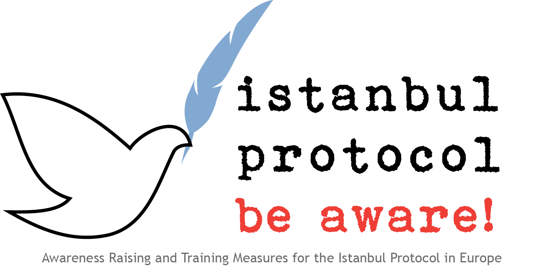

International Mechanisms and Procedures for Human Rights Monitoring

  - Catholic University Leuven

[page left blank on purpose]

This work is licensed under a
Creative Commons Attribution-NonCommercial-NoDerivs 3.0 Unported License.

This project has been funded with support from the European Commission. This communication reflects the views only of the author(s), and the Commission cannot be held responsible for any use which may be made of the information contained therein.

[page left blank on purpose]

TABLE OF CONTENT

1. Introduction 6
2. The protection of human rights through international monitoring 6
3. Overview of the most important international procedures 7
3.1 Reporting Procedures 7
3.2 Complaints Procedures 8
3.3 Inquiry Procedures 9
3.4 Other International Procedures 9

1. Introduction
There is no doubt that the different human rights provisions States adopt are meaningless without a good system of control and monitoring. Since the end of the Second World War a variety of mechanisms were set up to provide for a control system and take action in case of violations of human rights. These institutions and procedures operate in the framework of the United Nations as well as regional organisations for human rights, like the Council of Europe, the Organisation of American States, the African Union, etc.
This short chapter sketches some developments in international human rights monitoring and provides a concise overview of international procedures for such monitoring. It is against this double background that the monitoring system for torture and ill-treatment can better be understood.

2. The protection of human rights through international monitoring
In the course of the last 65 years, an impressive number of international mechanisms have been established in order to monitor the obligations of States with regard to human rights. This is foremost the case in the context of the United Nations, but also applies to regional organisations for human rights protection, like the Council of Europe, the Organisation of American States, the African Union, etc. However, this development was far from automatic and easy, and displays features of the erratic manner with which it has taken place.
Antonio Cançado Trindade, a former President of the Inter-American Court of Human Rights and currently a Judge at the International Court of Justice in The Hague, already in 1987 argued that the evolution of international control was linked to some important theoretical developments in international law. For example, the traditional doctrine of the national jurisdiction of States in the years 1950-1960 had to be delimitated in order to execute external control by several commissions and committees and several factors contributed to the erosion of this doctrine. First of all, at a theoretical level it proved important that States labelled the international mechanisms as subsidiary to national mechanisms, which of course implied that the primacy of supervision remained at national level. Secondly, various judicial techniques were developed to provide a certain flexibility to States before they had to subject themselves to international control, e.g. optional complaints procedures, derogatory clauses, etc. The decrease in importance of this State doctrine went hand in hand with two similar developments in international law, namely an increasing possibility for individuals to take part in international monitoring procedures and the increasing assertiveness of international institutions to undertake actions themselves in the field of human rights.
Many of these developments have been fostered by two major political developments: first, the era of decolonisation in the 1960s led the newly independent countries to reassert their national sovereignty, including the sovereignty over human rights matters; and secondly, the end of the Cold War and the fall of the Berlin wall in 1989 opened up new space for mutual cooperation and control in the sphere of human rights.
It is therefore clear that today’s system of international human rights monitoring is the result of both theoretical and political developments that illustrate the permanent tension between national and transnational interests.

3. Quick overview of international human rights procedures
Anyone looking at the organizational charts of the United Nations or regional organisations in the field of human rights runs the risk of being left with a sense of bewilderment, and possibly confusion. These charts resemble a labyrinth of institutions and procedures rather than providing a transparent building.
The following paragraphs give a quick overview of the three most important types of international procedures for human rights monitoring. It should provide more guidance for anyone interested in the international fight against torture to situate the various parts of the Istanbul Protocol against this background.

3.1 Reporting Procedures
The legal basis of these reporting procedures can be found in a number of important human rights conventions of the United Nations system, which illustrates that these procedures encompass a broad range of civil, political, economic, social, cultural and collective rights, including torture and ill-treatment:
- the International Convention on the Elimination of All Forms of Racial Discrimination;  - the International Covenant on Civil and Political Rights;  - the International Covenant on Economic, Social and Cultural Rights;  - the Convention on the Elimination of all Forms of Discrimination against Women;  - the Convention against Torture and Other Cruel, Inhuman or Degrading Treatment or Punishment;  - the Convention on the Rights of the Child;  - the International Convention on the Protection of the Rights of All Migrant Workers and Members of Their Families; and  - the Convention on the Rights of Persons with Disabilities. | - Read Art. 9 and Art. 15  - Read Art. 40  - Read Art. 16  - Read Art. 18  - Read Art. 19  - Read Art. 44
Reporting procedures require the contracting parties to report at regular intervals about the state of human rights in their country, in other words to give an overview of how human rights have been implemented, promoted and protected. This type of procedures can be regarded as the ‘regular’ or ‘normal’ system in international human rights monitoring as reporting is part of almost all important international conventions.
Here lies the strength of reporting procedures: they provide international monitoring bodies with a periodic overview of the human rights situation in the Member States of the diverse treaties. By doing so, they allow the monitoring bodies to raise critical questions at the next meeting where states have to present their national report, and to start the so-called ‘constructive dialogue’ between the monitoring bodies and the state.
However, reporting procedures also have weaknesses. The most important one is that the conclusions and recommendations issued by the monitoring bodies are not binding upon the states, at least not in legal terms. Another problem are the delays with which some state reports are submitted, which may lead to the strange situation that the monitoring body engages in a dialogue with the state on the basis of very outdated information.

3.2 Complaints Procedures
Complaints procedures constitute a second type of international monitoring. They allow that concrete cases concerning violations of human rights are handed over to international monitoring institutions. Complaints can be filed by States against other States (‘inter-state complaints’), and by individuals or groups of individuals against States (‘individual complaints’).
Not all human rights conventions contain a complaints procedure. In the United Nations system, e.g., only five of the major conventions provide the possibility for individuals to lodge complaints against the Contracting State:
- the International Convention on the Elimination of All Forms of Racial Discrimination;  - the International Covenant on Civil and Political Rights (in its Optional Protocol);  - the Convention against Torture and Other Cruel, Inhuman or Degrading Treatment or Punishment;  - the Convention on the Elimination of all Forms of Discrimination against Women; and  - the Convention on the Rights of Persons with Disabilities.  In practice these complaints procedures mainly focus on civil and political rights, and torture and ill-treatment are among them. The Optional Protocol establishing an individual complaints mechanism for economic, social and cultural rights has been adopted in 2008, but is not yet in force. Neither does the Convention on the Rights of the Child provide for a complaints procedure.  Apart from the UN system, some major human rights conventions in a regional context provide complaints procedures:  - the European Convention on Human Rights and Fundamental Freedoms;  - the American Convention on Human Rights;  - The African Charter on Human and People’s Rights. | - See art. 11 – Art. 16  - Read Art. 20-23  - Read Art. 34  - Read Art. 44  - Read Art. 55
Compared to reporting procedures, complaints procedures remain an exception in the international fight against violations of human rights. One of the reasons is that they tend to be optional, meaning that an additional acknowledgement by the States is required (like a special declaration or even ratification). A noticeable exception is the individual complaint procedure under the European Convention, which is no longer an optional procedure but an obligatory one for all Contracting Parties.
In the case of optional complaint procedures, it is clear that states retain the power not to accept them and thus bar individuals and groups from submitting complaints to the monitoring body. Another weakness of individual complaint procedures is that they may take very long before ending in a conclusion or a judgment. Proceedings that last 3 to 5 years, on top of lengthy national proceedings, are no exceptions.
However, it should be clear that complaints procedures, in particular the ones allowing individuals to bring their grievances to an international body, result in very specific decisions that may have far-reaching consequences for the human rights situation in states. Certainly the judgments of the European Court of Human Rights and the Inter-American Court of Human Rights are watched and read with great interest by legal professionals and human rights defenders all over the world.

3.3 Inquiry Procedures
A third form of international monitoring can be summarised under ‘inquiry procedures’. In the narrow sense, this term only applies to a limited number of committees (treaty bodies) that have the possibility to visit States Parties where there are indications of severe violations of the treaty. In particular, the Committee Against Torture and the Committee on the Elimination of Discrimination Against Women in the United Nations may, at their own initiative, initiate inquiries if they have received information on serious or systematic violations. The same applies to the European Committee for the Prevention of Torture, a supervisory body within the Council of Europe.
More important, however, are the so-called Special Procedures, which can also be said to constitute inquiry procedures. Some of these procedures focus on different forms of human rights violations in one specific country (‘country-specific procedures’), others focus on specific types of human rights violations worldwide (‘thematic procedures’). Some procedures are public, others are confidential. There are also differences in structure: one can distinguish working groups, special rapporteurs, special representatives and independent experts. Although there are many differences within these procedures, they all have one thing in common: they all aim at quick reactions (by telephone, fax, email or unexpected visits) to urgent problems when human rights violations are likely to occur, and in some cases they establish a proactive approach to preventing violations from taking place. In the area of torture and ill-treatment the important role of the UN Special Rapporteur on Torture cannot be overestimated.
Precisely the flexibility of their mandate and working procedures constitutes the main strength of these inquiry procedures. This flexibility allows them to adjust their working methods to the very concrete and urgent problems they are confronted with. In addition, no preceding ratification or approval by the States is necessary, since the Special Procedures have a mandate that covers all Member States of the United Nations or the corresponding regional system like the Organisation of American States or the African Unity.
Nevertheless, inquire procedures also possess weaknesses. Some can only enter into operation if they have an invitation from the States concerned in order to conduct their inquiries. Additionally, inquiry procedures are often limited in terms of resources and at times under serious political pressure from States as well as from their parent body.

3.4 Other International Procedures
The above mentioned procedures were designed in the last decades to monitor the obligations of States with regard to human rights. More recently, in the last twenty years, a number of interesting developments have taken place to highlight also the responsibility of individuals with regard to these human rights. The best example in the international fight against human rights violations is the establishment of two international ad-hoc tribunals, namely those for the former Yugoslavia (ICTY) and Rwanda (ICTR). Both of them can be seen as the predecessors of the permanent International Criminal Court (ICC).
The tribunal for the former Yugoslavia and the tribunal for Rwanda find their legal basis in two UN Security Council resolutions in the early 1990s following the wars in ex-Yugoslavia and the genocide in Rwanda. The ICC was established by the Rome Statute in 1998. The objective of these procedures lies in holding individual perpetrators liable for severe violations of human rights such as war crimes, crimes against humanity or genocide. | - For more information on the ICTY, visit the website www.icty.org  - Visit the website www.unictr.org for more information on the ICTR.
Their strength of course lies in their judicial competence to adjudicate on an individual’s responsibility for severe violations of human rights and thus reduce impunity.
Their weakness is that they can only take into consideration a limited number of cases and that the criminal proceedings may take a very long time.

Antonio Augusto Cançado Trindade (1987) Co-existence and Co-ordination of Mechanisms of International Protection of Human Rights (at Global and Regional Levels) 202 Collected Courses of The Hague Academy of International Law 1-435, 34.

