Exercise 1 – ARTIP Training
Istanbul Protocol Basic I
Assesses basic understanding of core components in the Istanbul Protocol.

Question: 1
What is the Istanbul Protocol ?
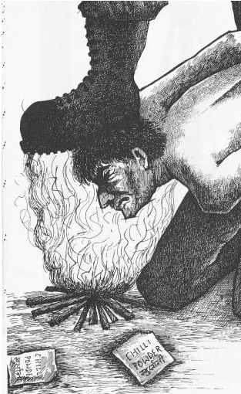
Choice |  | Answer
 |  | An international treaty
 |  | A training standard
 |  | A handbook of medical treatment of torture victims

Question: 2
Mental health is part of all investigation because...
Choice |  | Answer
 |  | Psychological reaction to torture (psychological trauma) can interfere with memory and reporting
 |  | Psychological reaction to torture (psychological trauma)is part of the evidence
 |  | Psychological reaction to torture (psychological trauma) is an important aspect to be considered because of its frequency

Question: 3
The IP consists of....
Choice |  | Answer
 |  | Medical information
 |  | Legal Information
 |  | Psychological information
 |  | Treatment guidelines

Question: 4
Torture is...
Choice |  | Answer
 |  | Permitted if lives are in danger
 |  | Permitted, if ordered by a court of law
 |  | Not permitted under any circumstances what so ever

Question: 5
The Istanbul protocol consists of...
Choice |  | Answer
 |  | Separate chapters for lawyers and health care professionals
 |  | Chapters with different focus relevant for all professionals
 |  | The complete texts of international human rights standards

Question: 6
The IP was created by...
Choice |  | Answer
 |  | A legal team
 |  | A medical expert team
 |  | An interdisciplinary team

Question: 7
The IP Annexes include..
Choice |  | Answer
 |  | A chapter on Diagnostic tests.
 |  | A chapter of anatomical drawings
 |  | Guidelines for the medical evaluation of torture and ill-treatment
 |  | A treatment manual

Question: 8
The IP is offically supported
Choice |  | Answer
 |  | The World Medical Association
 |  | The World Psychiatric Association
 |  | The United Nations
 |  | The International Rehabilitation Council for Torture Survivors

Question: 9
Physicians..
Choice |  | Answer
 |  | Have to agree to monitor health in ongoing torture
 |  | Have to follow orders if commanded not to document torure by higher authorities
 |  | Are not permitted to participate in torture or hide use of torture
 |  | Are permitted to support torture if lives are in danger
 |  | Have to take all efforts to stop, document and report torture

Question: 10
For members of the legal profession...

Choice |  | Answer
 |  | No international standards exist for professional behaviour that is only regulated by country law and bar associations
 |  | International standards apply

