Exercise 2 – ARTIP Training
Istanbul Protocol Mental Health Basic
Ten questions on key aspects of mental health in the IP

Question: 1
Why is the mental health (psychological) assessment important
This execrises covers key points of mental health
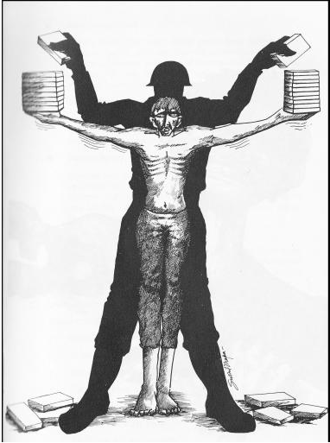
Choice |  | Answer
 |  | Mental health problems can interfere with memory and reporting, leading to incomplete narrative, difficulties to follow the interview or contradictions
 |  | Psychological trauma can be part of the evidence
 |  | All survivors are crazy because of what they experienced
 |  | Immediate intervention and support might be needed, such as in case of suicidality

Question: 2
Irritability and concentration difficulties can indicate..
Choice |  | Answer
 |  | Posttraumatic Stress Disorder
 |  | Brain Trauma

Question: 3
Post Traumatic Stress Disorder is...
Choice |  | Answer
 |  | the only relevant and characteristic sequel to torture
 |  | one of the common reactive disorders resulting from torture
 |  | only indicator of psychological trauma
Question Score: 0/1

Question: 4
Common psychological sequels after torture include..
Choice |  | Answer
 |  | Posttraumatic stress disorder
 |  | Schizophrenia
 |  | Depression

Question: 5
Posttraumatic Stress Disorder Symptoms include..
Choice |  | Answer
 |  | Strong memories coming up (flash backs)
 |  | Nightmares
 |  | Hallucinations
 |  | Increased irritability and startle response
 |  | Avoidance of situations reminding of torture

Question: 6
Emotional sequels can include...
Choice |  | Answer
 |  | Shame feelings
 |  | Guilt feelings
 |  | Loss of self confidence
 |  | Loss of a feeling of meaning in life

Question: 7
Culture..
Choice |  | Answer
 |  | plays no role in psychological sequels, all sequels can arise in all cultures
 |  | influences disorders observed, interaction and presentation of symptoms
 |  | can shape specific reactions ("idioms of distress")

Question: 8
If a client does not suffer from PTSD...
Choice |  | Answer
 |  | he has not been tortured
 |  | he might have recovered from PTSD
 |  | he has been tortured but did not develop PTSD

Question: 9
Symptoms of depression after torture can include..
Choice |  | Answer
 |  | Sadness and depressed mood
 |  | Hallucinations
 |  | Lack of energy
 |  | Diarrhoea
 |  | Difficulties with concentration

Question: 10
Post Traumatic Stress Disorder..

Choice |  | Answer
 |  | can be diagnosed only by Magnetic Resonance Imaging (MRI)
 |  | can in most cases be diagnosed through the interview by an experienced health care professional
 |  | can only be diagnosed by a Psychiatrist
 |  | qzestionnaires are available to help with a diagnosis

