Exercise 3 – ARTIP Training
Physical examination..
Key points in the physical examination

Question: 1
The physical examination..
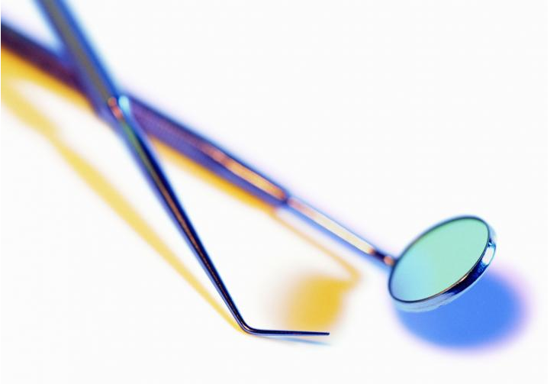
Choice |  | Answer
 |  | Should be conducted as sensitive as possible
 |  | A thorough examination is more important then the emotions of the client as it serves truth

Question: 2
Torture..
Choice |  | Answer
 |  | must always lead to lasting injuries
 |  | can result in injuries that might vanish after time or treatment
 |  | techniques can be designed to avoid traces by teh perpetrators

Question: 3
Common physical forms of torture include..
Choice |  | Answer
 |  | hanging
 |  | beatings
 |  | submersion until the victim nearly drowns
 |  | burning with cigarettes
 |  | use of Psychiatric medication

Question: 4
A negative finding after alleged beatings proofs..

Choice |  | Answer
 |  | The client must be lying
 |  | Injuries might have healed
 |  | Memories might be confused due to posttraumatic stress or disorientation
 |  | Additional examination methods might be required

Question: 5
A negative finding after alleged beatings might indicate..

Choice |  | Answer
 |  | injuries have healed over time
 |  | injuries might have been treated successfully
 |  | reported events might have been remembered incorrectly because of stress, disorientation or brain injury
 |  | the client might be lying
 |  | examination methodology might be insufficient

Question: 6
Falanga means..
Choice |  | Answer
 |  | beatings of a hanging body
 |  | Beatings to the soles of the feet with cables, sticks or other instruments

Question: 7
Falanga can lead to..
Choice |  | Answer
 |  | Pain located in the feet and lower leg
 |  | Pain in the abdominal region
 |  | Lower back pain

Question: 8
Bone szintigraphy is..
Choice |  | Answer
 |  | A radiological method to detect bone injury not recognised by normal X-ray
 |  | Can be used to detect damage to the brain
 |  | Can proof that no torture occured if results are negative

Question: 9
Documentation can be improved by ..
Choice |  | Answer
 |  | using a forensic ruler or other tools to include a scale and colour reference in a picture
 |  | exact body maps to document injuries
 |  | samples of body maps are part of the Istanbul Protocol Annex

Question: 10
Undue stress in examinations can be avoided by..
Choice |  | Answer
 |  | giving exact information on who you are and what is going to happen
 |  | offering the option of taking breaks if distress caused by memories of torture becomes too high
 |  | ordering the client to comply with all demands to be able to help with his case
 |  | being aware that many examination steps can trigger memories of torture, especially in the vaginal region, penis and anal region

